Collections:-

Need of Collections

===================

===================

Arrays:

======

Student[] s = new Student[1000];

Limitations

===========

1)Fixed in size

2)Accepts Homogeneous type of data, but can be solved using object arrays.

=============

example:- Object[] a = new Object[1000];

a[0] = new Student();

a[1] = new Customer();

3)There is no underlying DataStructure so, ready made method support is unavailable;

Collections

===========

1) Collections size are not fixed

2) Collections holds both homogeneous & hetrogeneous data

3) Follows Standard DS

4) By using arrays we can hold bot primitives and objects but with vollection we can hold only Objects

""Collection is a group of Individual Objects""

>>9 Key Interfaces of Collection Framework

==========================================

1) Collection(Interface):- when you need to represent group of indivitual object as a single entity

=====================

>Diff b/w collection & Collections:

Collections:- it is a Utility class to serve several utility methods(Seraching, Sorting) for collection objects

===========

2) List(Interface):- when we want group of individual objects represented as single entity where duplication is allowed and insertion order is preserved.

==================

3) Set(Interface):- does no allow duplication and no insertion is preserved.

===================

4) Sorted Set(Interface):- No duplication allowed but inserted according to some sorting order

========================

5) Navigable Set:- child interface of sorted set. defines several methods for navigation purposes.

=================

6) Queue:- Represent group of individual objects prior to processing.(FIFO)

==========

7) Map Interface:- Not child Interface of Collection.

================ If we want to represent group of objects as key and value pairs then we have to go for map Interface. where both key and values are object, keys cannot be duplicated

values can be duplicated.

8) Sorted Map:- Key value pairs are sorted according to sorted value of keys

==========

9) Navigable Map:- Child Interface of Sorted map, defines several utility methods for navigation purpose.

=============

>> Difference between Comparable and Comparator

===============================================

\* If we have to go for default sorting order we go for Comparable

\* If we have to go for customized sorting order we go for Comparator

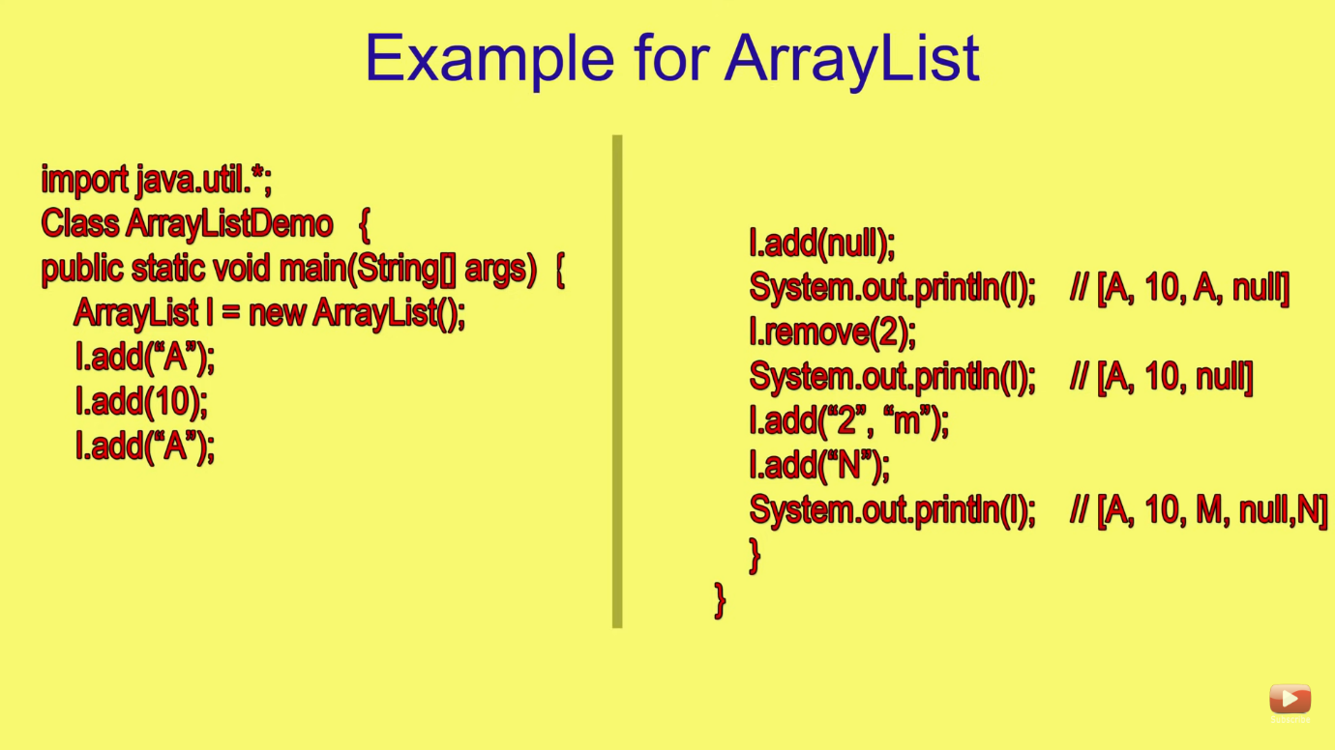

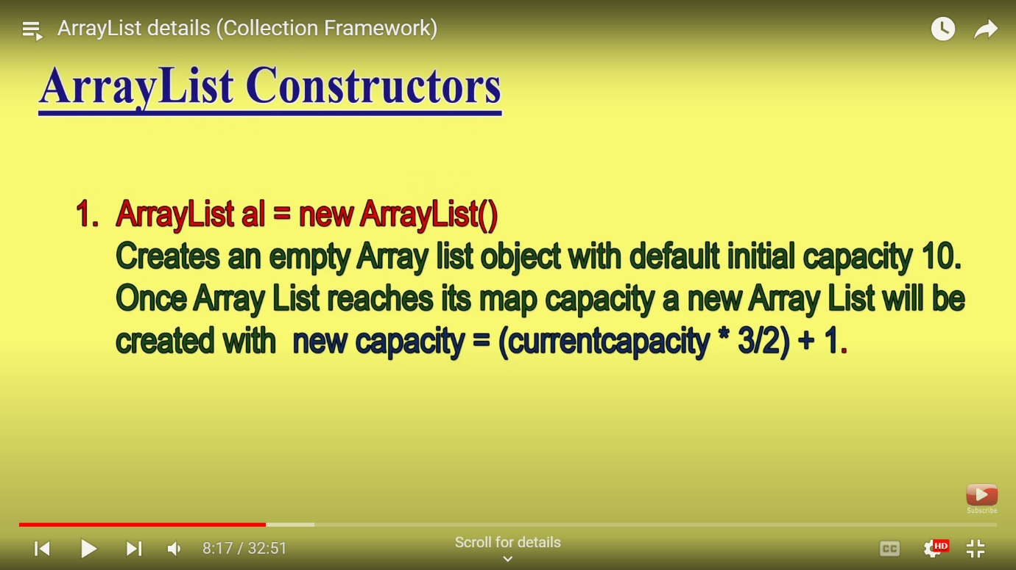

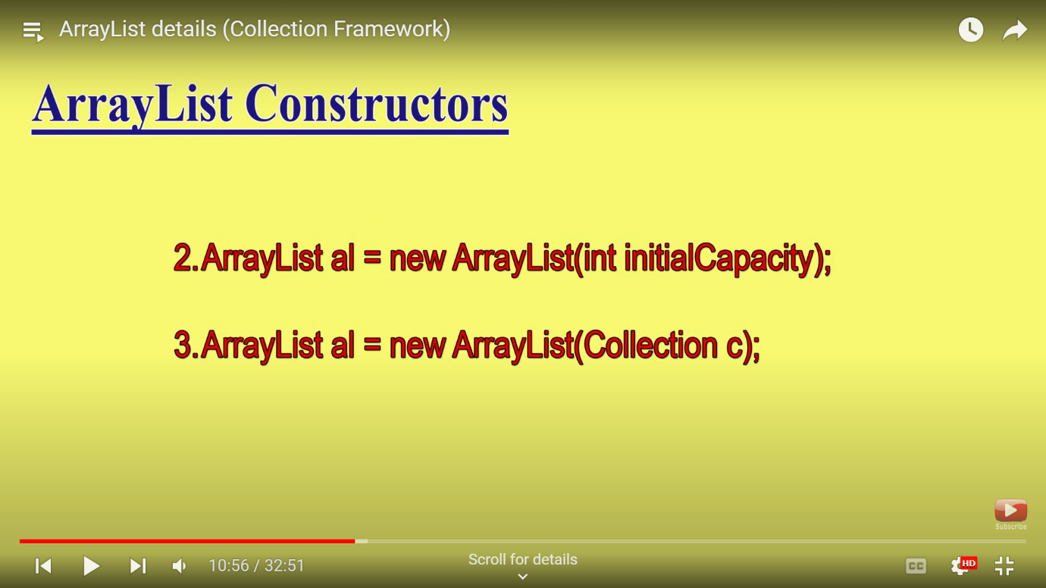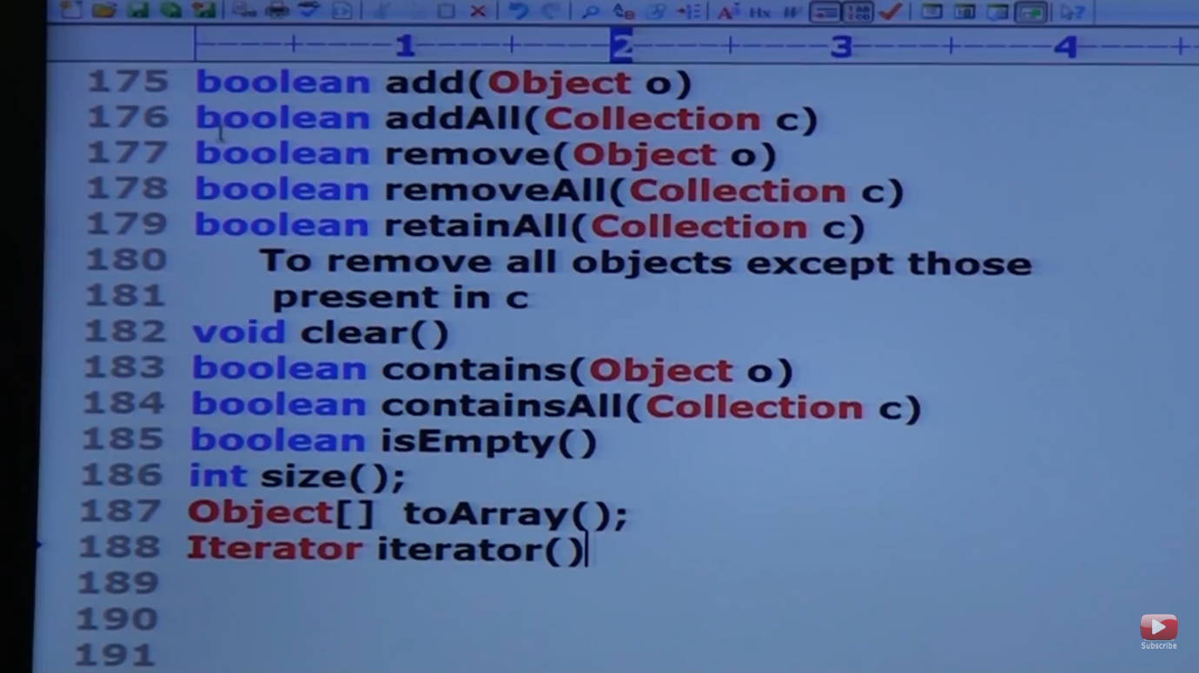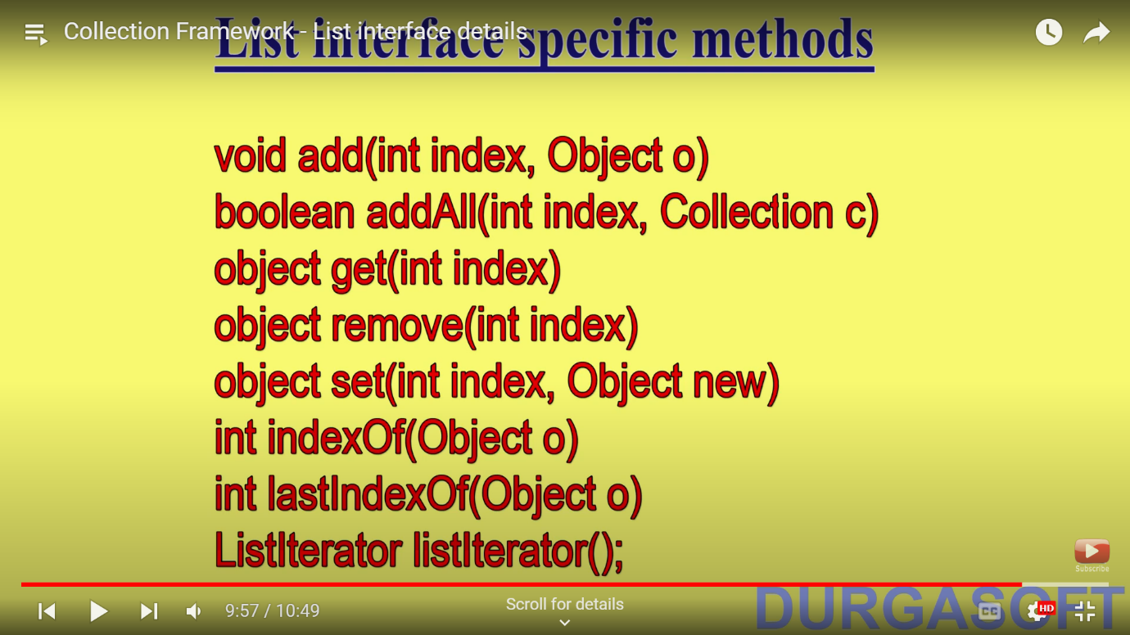

MAPS: 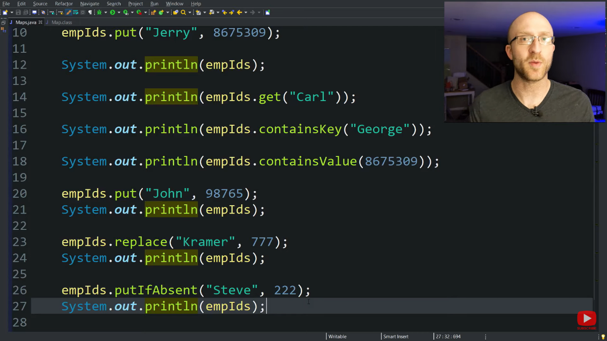-

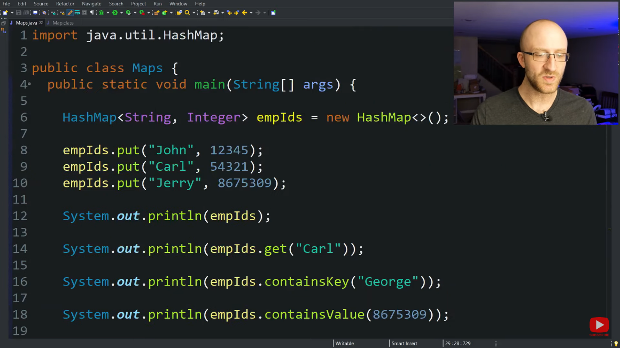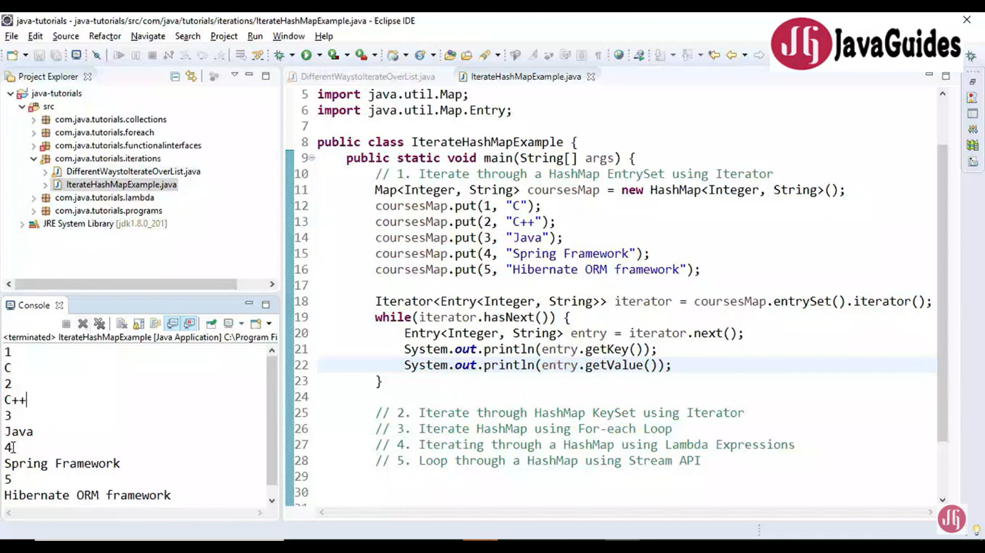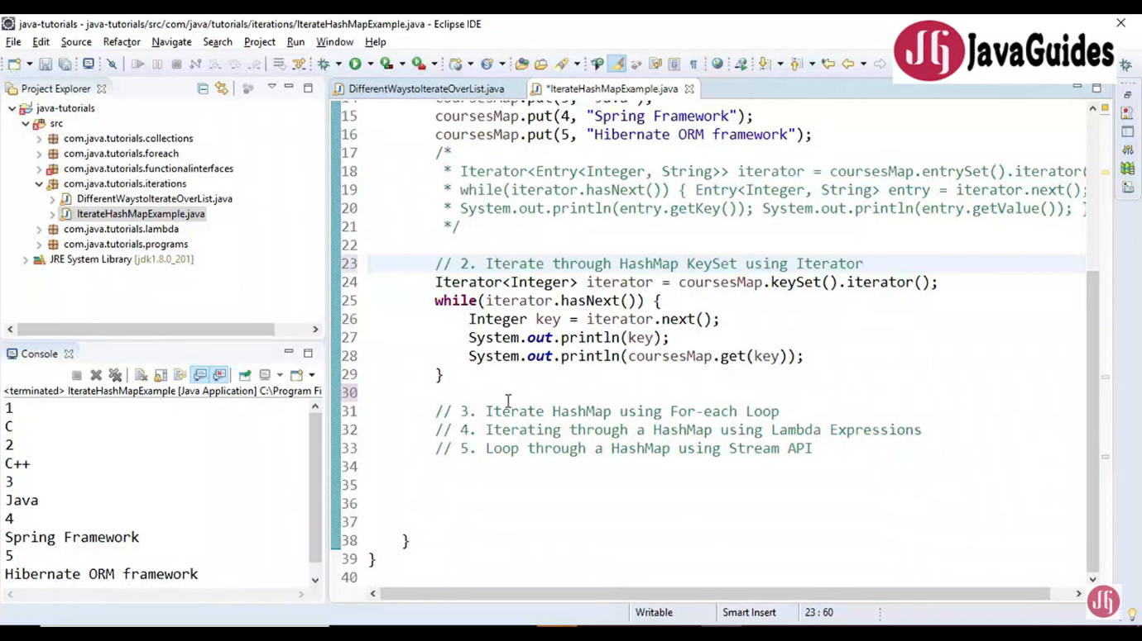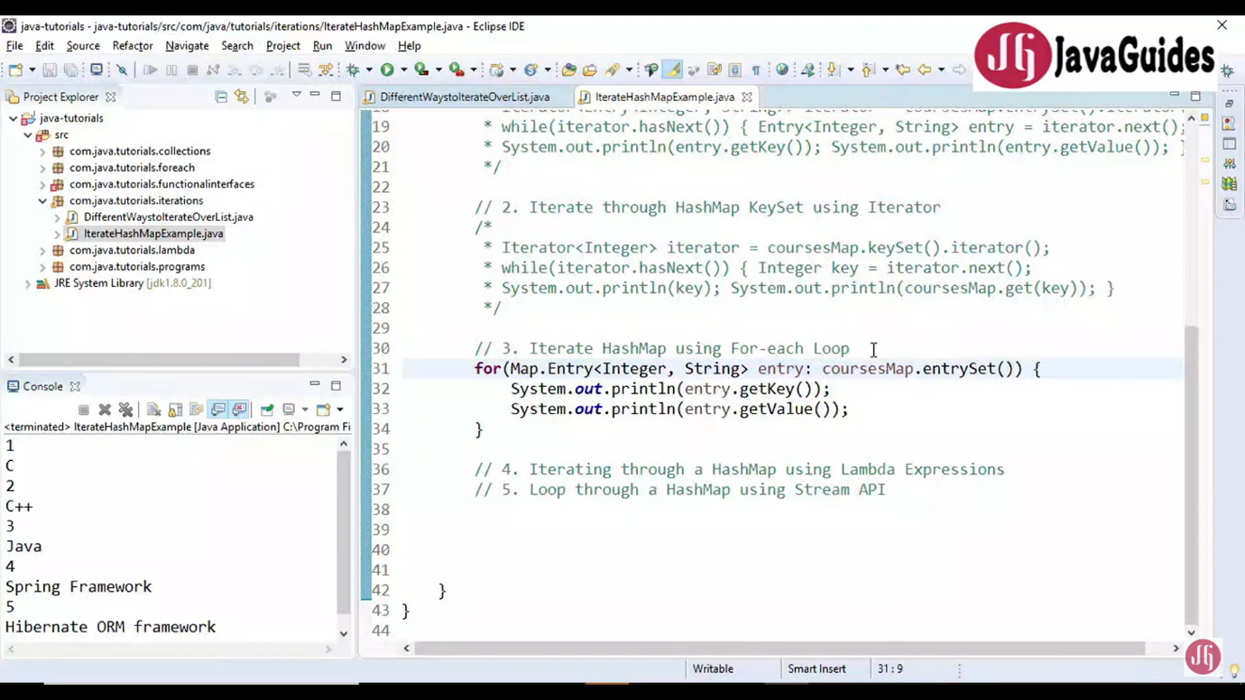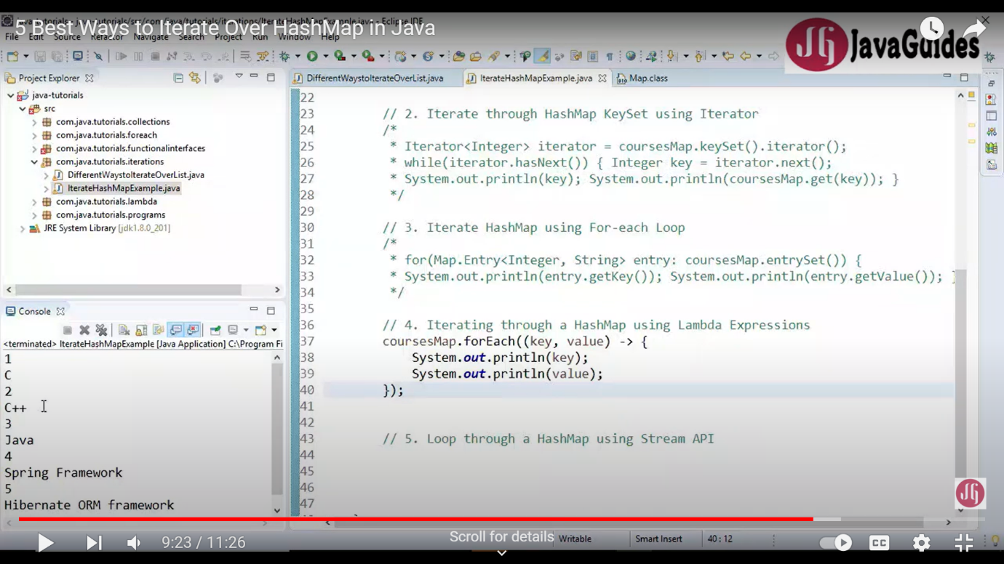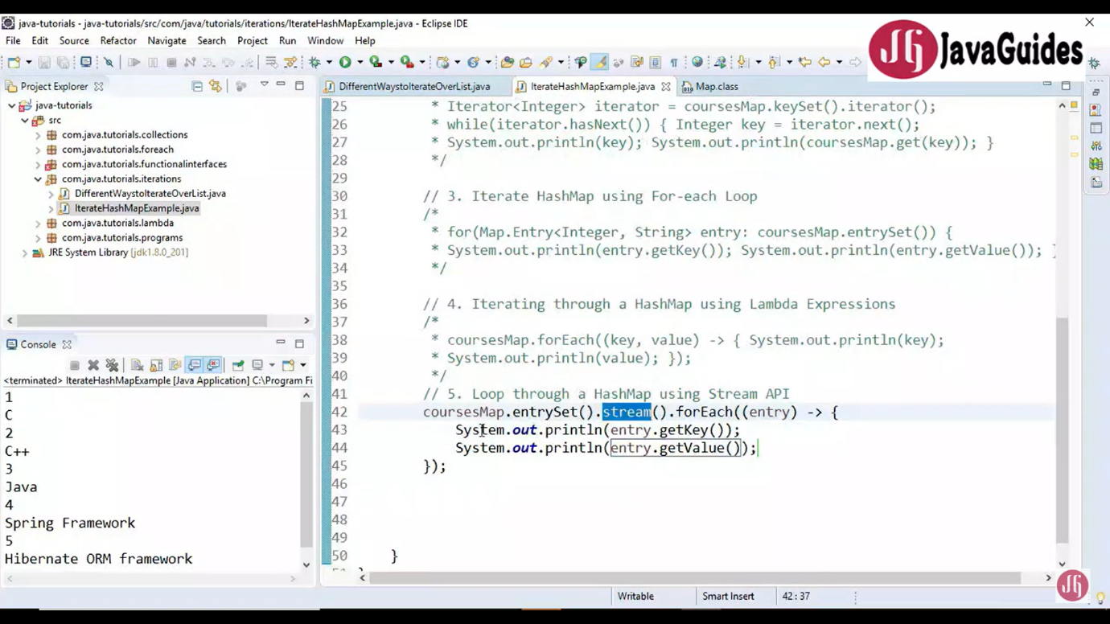

Sets

